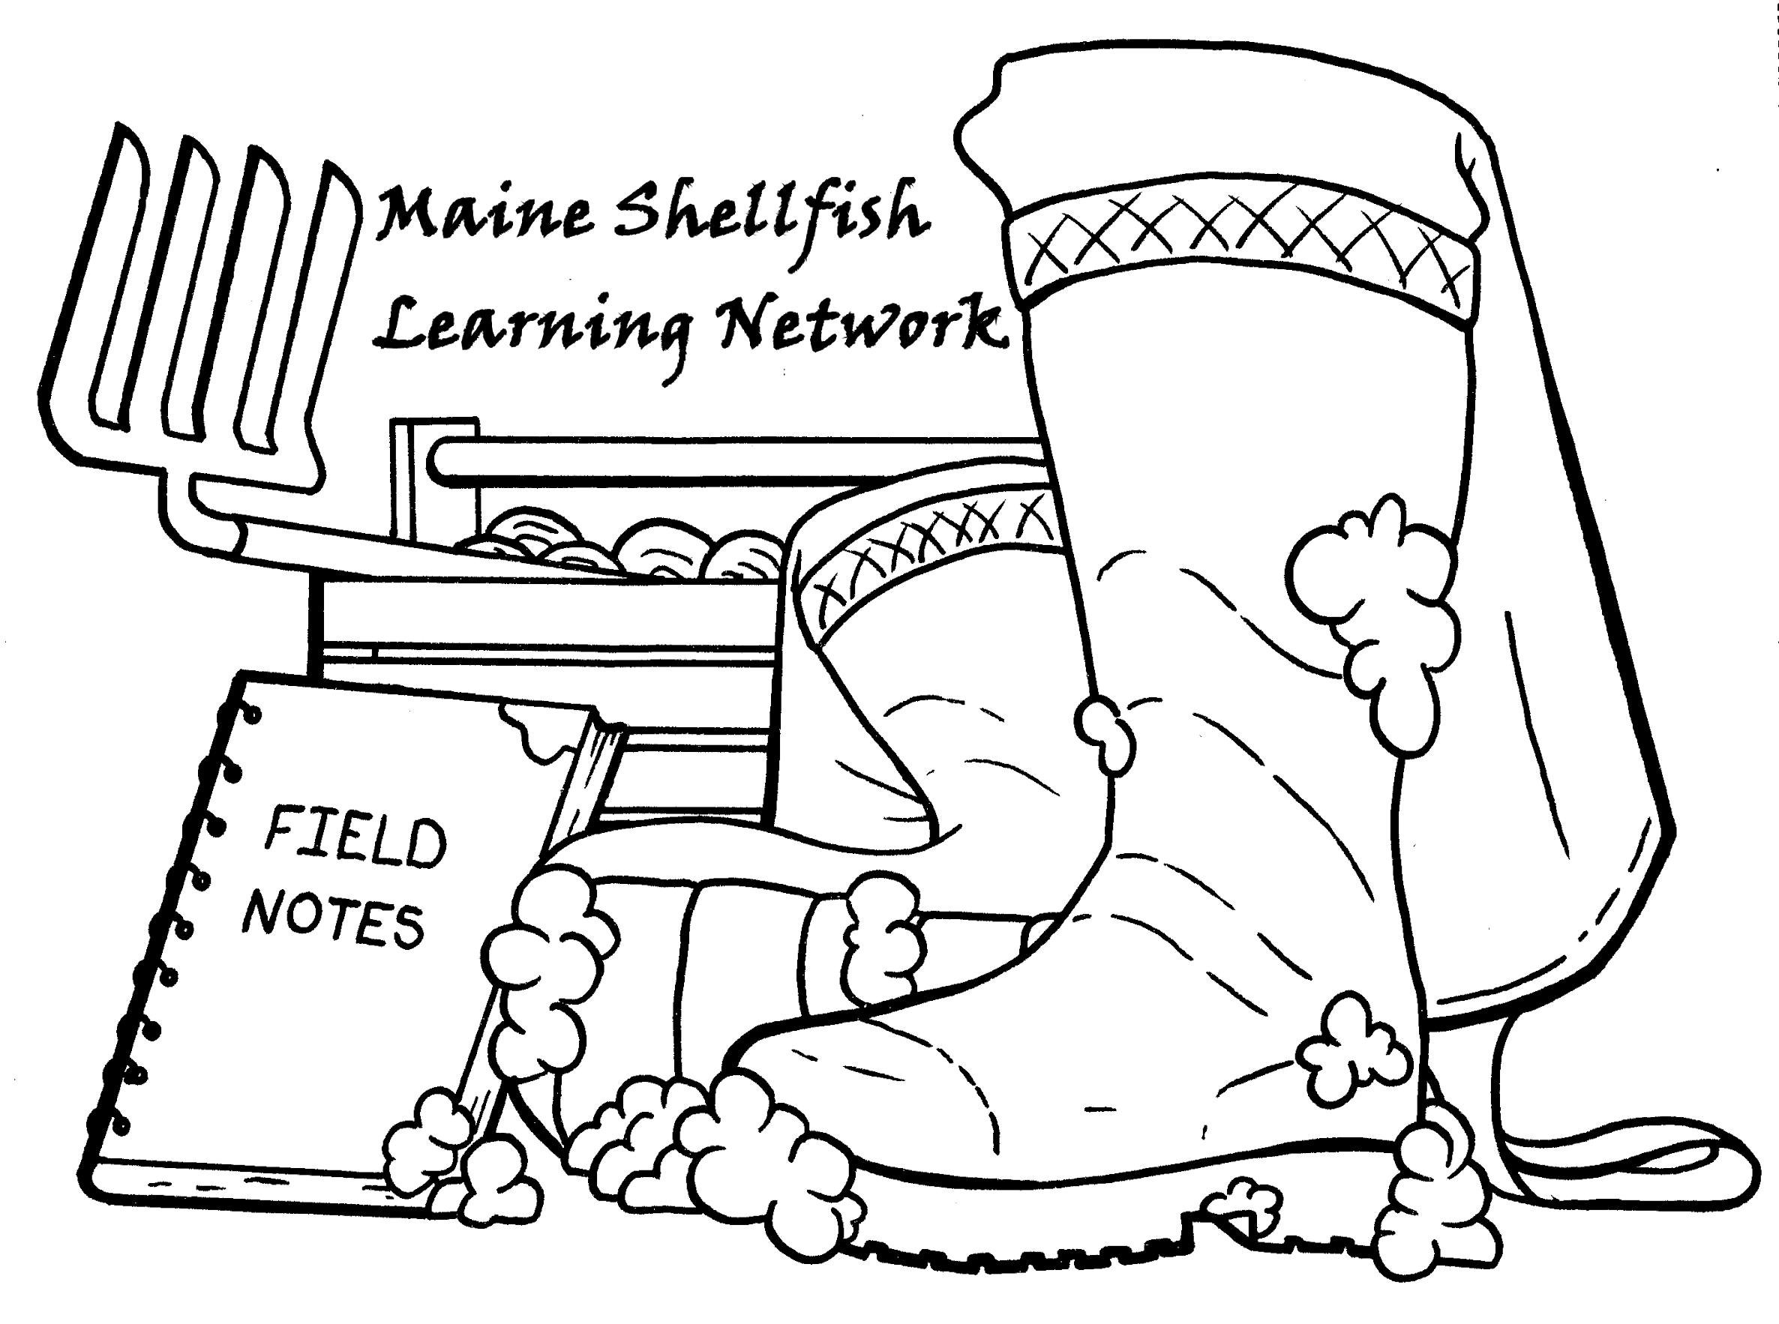

Water Quality Project Support Tool

Completed in collaboration from the Maine Shellfish Learning Network (MSLN)

Table of Contents

Acknowledgements………………………………………………………………………………………2
Introduction………………………………………………………………………………………………..3
Using the Workbook……………………………………………………………………………………...5
Pollution……………………………………………………………………………………………….......6
Who Is Involved ………………………………………...………………………………………………..8
Water Quality Management …. ……………………………………………………………………….10
Non-Point Source Pollution Help…………………………..………………………...…………...…...12
Point Source Pollution Help………………………………...…………………………..……….……..15
Water Quality Information Types……………………………………………………………………....17

For questions about this workbook or how it works please contact:

Gabrielle Hillyer
gabrielle.hillyer@maine.edu

Bridie McGreavy
bridie.mcgreavy@maine.edu

Acknowledgements

There were many people involved in creating this document. First, the MSLN would like to thank all of the participants and partners at the September 2019 MSLN meeting who were able to highlight this need in the shellfish community and direct our focus. The MSLN would also like to thank Bryant Lewis (DMR), Geoffrey Shook (DMR), Meryl Grady (DMR), Brent Lawson (DHHS), Matt Randall (DACF), Pam Parker (DEP), and Kendall Marden (MDIFW) for all their help, guidance, and time spent on developing this workbook.
Introduction to Workbook

This water quality decision support tool functions as a guide for local communities in Maine who want to improve water quality scores and open closed clam flat areas. This is in no way a guarantee, however, this provides a realistic view of the multiple steps needed to reopen flats impacted by non-point source pollution and point-source pollution. It should be used as a guide to understand the complexity of water quality issues in Maine, and serve as a starting point for communities to understand what steps to take to try to mitigate those issues. This workbook is also available online, at the web address below.

https://mudflatsinmaine.wordpress.com/water-quality-decision-support/

The idea for this workbook was generated by a priority action item meeting held in September 2019 by the Maine Shellfish Learning Network (MSLN). At that meeting, it was determined that the number one priority for the MSLN should be connecting key actors in water quality decision making and shellfish project permit regulation. This is described in the snapshot from meeting notes below:

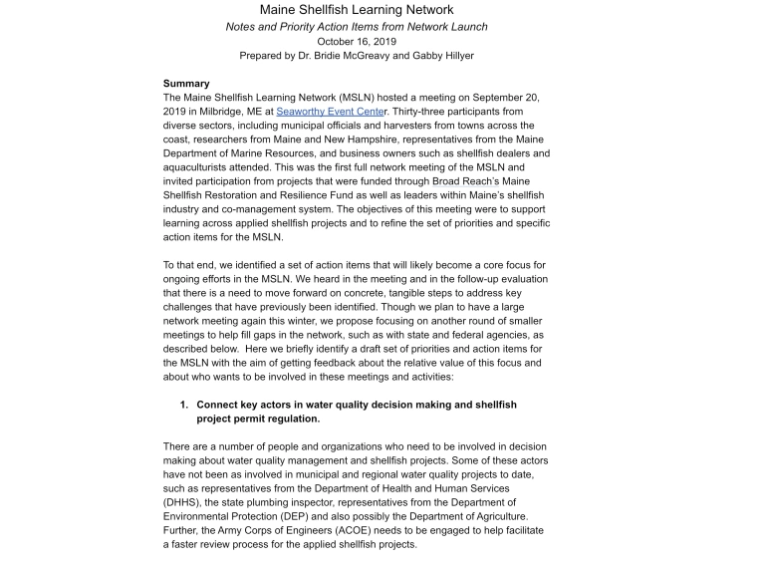

Addressing this action item, the MSLN convened a meeting between multiple state agency representatives to discuss the issue of water quality projects around the coast of Maine. From there, it was determined that the goal for the “Water Quality Group” should be to develop a decision support tree for communities, which progressed into this workbook, and subsequent online resources.

This workbook represents a collaboration between the MSLN, the Maine Department of Marine Resources (DMR), the Maine Department of Environmental Protection (DEP), the Maine Department of Health and Human Services (DHHS), the Maine Department of Inland Fisheries and Wildlife, and the Maine Department of Agriculture, Conservation and Forestry. Please visit each of their websites, listed below, for any additional information specific to these agencies.

The Maine Department of Marine Resources
https://www.maine.gov/dmr/

The Maine Department of Environmental Protection
https://www.maine.gov/dep/

The Maine Department of Health and Human Services
https://www.maine.gov/dhhs/

The Maine Department of Inland Fisheries and Wildlife
https://www.maine.gov/ifw/

The Department of Agriculture, Conservation and Forestry
https://www.maine.gov/dacf/

Using the Workbook

This workbook is a support document, meaning it should be a first step for communities to understand water quality issues. It is recommended that after reviewing this document thoroughly, shellfish committees should reach out to town offices for additional information, as well as their area biologists.

Information

The first few sections of this workbook describe what pollution is, possible sources for pollution, and what non-point and point source pollution means. It also describes the various governmental agencies involved in water quality work. As a starting point, there are many different resources to further describe each of these themes in detail, particularly governmental websites (previous page).

Pollution Help

Later sections describe steps communities can take to find and fix pollution sources. It should be noted there is no guarantee clam flats will be reopened after completing these steps. However, these have proven success in towns like Waldoboro, ME. This process can be long, over many years, and there is no one-size-fits all solution. Instead, this is a loose guide which should help committees determine which projects could be profitable.
Pollution

What is Pollution?

Pollution in this context is any material that is entering the river and increasing bacteria counts. The Department of Marine Resources (DMR) measures water quality throughout the year, taking samples from specific stations, and adjusting shellfish closures types from those samples.

Types of Pollution

Non-Point Source

Non-point source pollution occurs as a result of runoff. Water runs through multiple spaces and picks up bacteria, animal waste, chemicals, and other harmful substances. This water then ends up in rivers and estuaries, impacting clam flats. This type of pollution is particularly difficult to manage because it comes from so many different places. The amount of harmful substances may be relatively low compared to point sources. After further exploration in an area where the source of pollution is unknown, it is possible to find a point source, which is described in the next section. For example, if one cove has pollution problems, a shoreline survey in the area can lead to the discovery of a broken sewer system from a nearby home. The picture below describes non-point source pollution, and how it can be very difficult to determine where it is coming from.

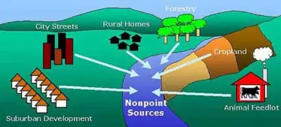
https://oceanservice.noaa.gov/education/tutorial_pollution/welcome.html

Point Source

Point source pollution is any pollution that has an easily identifiable source. This pollution is usually easier to fix because you are able to monitor the source. Point source pollution can include drain pipes, ditches, sewer outfalls, factories, power plants, and others. There are multiple grants and state agency departments that can help once a point-source has been identified. Below, there is a diagram with common discharges of point source pollution in the United States.

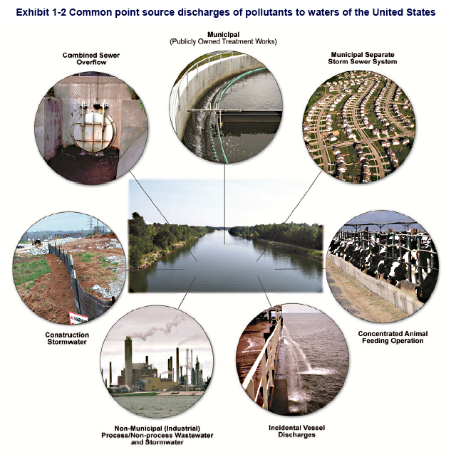

U.S. Environmental Protection Agency, Washington, D.C. – U.S. Environmental Protection Agency, “NPDES Permit Writers Manual.” EPA 833-K-10-001. p. 1-8.
Photos depicting common types of point source dischargers to surface waters in the United States. These facilities are required to obtain discharge permits from the National Pollutant Discharge Elimination System (NPDES).

Who is Involved?

There are many different state agencies involved in water quality management. This short guide provides a bit of detail on each of the different agencies, people to contact for specific questions, as well as an outline of the responsibilities of each agency.

Shellfish Communities

There are over 60 coastal communities with shellfish ordinances in Maine. Generally, this requires the creation of the marine resource or shellfish committee, and a shellfish ordinance that discusses species harvested, specific localized restrictions, and licensing information. Shellfish communities are generally responsible for a lot of the leg work in terms of resolving water quality issues. This is done through extensive scientific projects, either increased water testing, surveying shorelines for any specific pollution problems or other methods.

State Agencies

The Maine Department of Marine Resources (DMR)

The DMR is an organization established to conserve and develop marine and estuarine resources and advise and cooperate with local, state, and federal officials concerning activities in coastal waters. The DMR oversees water quality testing and regulation, and makes decisions around water quality closures. The DMR also advises the Shellfish Advisory Council on different legislative proposals to State management.

The Maine Department of Environmental Protection (DEP)

The DEP is an organization focused on environmental protection. In shellfish management, DEP focuses on enforcement around rivers and sewage systems. Members of the DEP have often collaborated with towns to facilitate waste discharge restoration projects as well as others.

The Maine Department of Health and Human Services (DHHS)

The Department of Health and Human Services (DHHS) through the Maine Subsurface Wastewater Team, works to test and determine if subsurface sewage systems are depositing fecal coliform bacteria into nearby soils, estuaries, or rivers.

The Maine Department of Inland Fisheries and Wildlife (MDIFW)

The Department of Inland Fisheries and Wildlife (MDIFW) does not have any direct management over the soft-shell clam fishery or other coastal fisheries. However, they should be consulted if wildlife is determined to be the source of water quality issues, in order to find if remediation is possible. For example, if a town were to find a flock of geese or beaver dam were creating a water quality issue, the MDIFW should be consulted to understand how to approach that problem.

The Maine Department of Agriculture, Conservation, and Forestry

The Department of Agriculture, Conservation and Forestry (DACF) does not directly manage the soft-shell clam fishery, but can help communities who believe water quality issues can be attributed to agriculture. This is rarely the case, however, this agency works well in devising plans with community members and farmers to create workable solutions.

Water Quality Management

How is water quality managed in the State of Maine? In the fields below, the MSLN hopes to provide some general information on policy regarding water quality, shellfish area closures, and different state and national programs.

Water Quality Management in Maine

National Shellfish Sanitation Program

The National Shellfish and Sanitation Program (NSSP) was developed at the federal level from the U.S. Food and Drug Administration, and created a series of nationwide laws which protect consumers from any shellfish contaminated with pollution.

Maine Department of Marine Resources

The Maine Department of Marine Resources (DMR) oversees the application of the NSSP within the context of Maine’s shellfishery. Specifically, the DMR monitors for biotoxins such as “red tide”, and water quality. The DMR assigns stations within mudflats and samples water at each station on an annual basis. Each water sample is tested for fecal coliform bacteria, a variety of bacteria that come from fecal pollution in the water. These scores are then processed within a p90 statistical analysis. This analysis takes 90% of 30 individual tests and assigns a final score. 30 individual tests at a station usually means about 5 years of testing. Depending on the score, the DMR will close, open, or conditionally open clam flat areas.

Types of Closures

As stated in the section above, there are multiple types of closures depending on the final score from the p90 of a station. Below, we describe each of these closures. Colony forming units (CFU) of fecal coliform bacteria are measured from water samples taken by the DMR. Closures are then determined based on these numbers.

Prohibited

A Prohibited closure means that the final p90 score is greater than 163 CFU/100 mL. This number is derived from the NSSP. Prohibited areas are not allowed to be fished in any capacity until the p90 drops lower than 163 CFU/100mL. There are also prohibited areas that are policy closures due to the presence of point source pollution, for example a dilution area around a marina or active overboard discharges. In the map above, these are areas in red.

Conditional

Conditional approved or conditionally restricted areas are areas that can be temporarily closed based on environmental conditions that can be managed. For example, in Maine, conditional closures can be managed based on rainfall, season, the presence of a marina, astronomical high tides, or river flow. Runoff, in this instance, means when rainwater flows out to the river estuary and mudflats, carrying pollution. In certain areas across the coast, clam-meat studies were done in order to change the timing of closures. For example, in the Medomak River, conditionally approved areas are closed when rainfall meets or exceeds 1″ within a 24-hour period, and are closed for 9 days. In the map above, these areas are designated by a blue grid.

Flood Closure

Flood closures close when rainfall meets or exceeds 2″ (5cm) in a 24-hour period due to the potential for fecal coliform pollution caused by runoff. This is a policy in Maine, so it happens throughout the state. Reopening after a flood closure is based on sampling by the DMR.

Restricted

These are areas that are greater than 31 and less than 164 CFU / 100mL, but you are able to harvest with a special DMR permit for depuration digging. In the map above, these areas are designated with a green grid.
Non-Point Source Pollution Help

This guide is intended to help communities who are working to resolve water quality issues particular to non-point source pollution. The graphic below describes briefly the different steps a community would need to take to better understand pollution sources and possibly mitigate pollution closures.

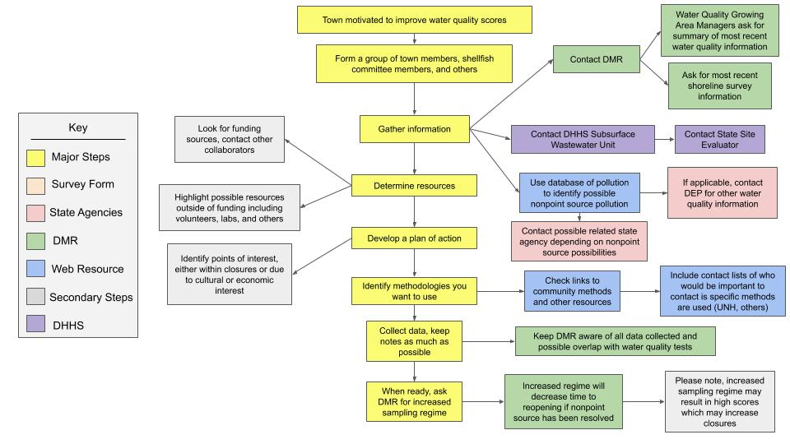
This graphic highlights the major steps any community trying to help solve water quality issues should be taking. More details are posted below.

Steps To Take

This guide outlines 8 major steps for each community to take. This is by no means exhaustive, and it should be noted there is no guarantee for clam flats to be reopened if a community or group follows all of these steps.

Form a Team

Any effort to resolve non-point source pollution will be long and may span multiple seasons or even years. So, having a group of individuals who are invested and similarly motivated helps to keep the effort moving forward. For example, a team may include representatives from the shellfish committee, local municipal leaders, a member of the MSLN team, and other invested community members.

Gather Information

Before beginning any specific actions, the group should gather as much information as possible. This may include contacting multiple state agency representatives, involving local municipal managers, and researching a number of different document types. For a breakdown of information you may be looking for, please see our Water Quality Information Guide on page 13.

Determine Resources

Resources are anything that can be used to a group's advantage, including funding, volunteers, laboratories and others.

Develop a Plan of Action

This is the major planning stage. The group should collectively identify areas of interest, or any area that is socially, economically, or culturally important to the group. The group should then follow the next step of understanding how to ascertain more information about the pollution problem, and fix it.

Identify Methodologies

There are so many different ways to find pollution problems out there. The MSLN has started gathering technical briefs, which are documents that identify multiple methods communities have used, and give details such as cost, time, etc. Below, we have outlined potential methodologies in specific areas around mudflats.
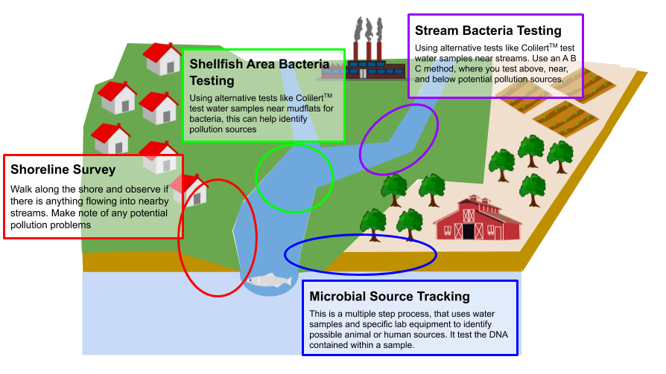
This graphic highlights where different techniques could be used for different water quality efforts. Please visit the Technical Resource page to find documents highlighting these different techniques.

Collect Data

This stage is where you implement the plan of action. This can include multiple field days, extensive manual labor, or collaboration with various scientific institutions. During this stage, shellfish communities should contact their local DMR representative and keep them up to date during the data collection process.

Ask the DMR

If remediation work has been taken, DMR can be requested to take additional samples to more quickly replace pre-remediation scores in P90 calculations. This may decrease the time to reopen or reclassify a harvesting area if the non-point source has been resolved. Please note, an increased sampling may result in new high scores which may increase closures. DMR has limited capacity so these requests cannot always be met.
Point Source Pollution Help

This guide is intended to help communities who are working to resolve water quality issues particular to point source pollution.
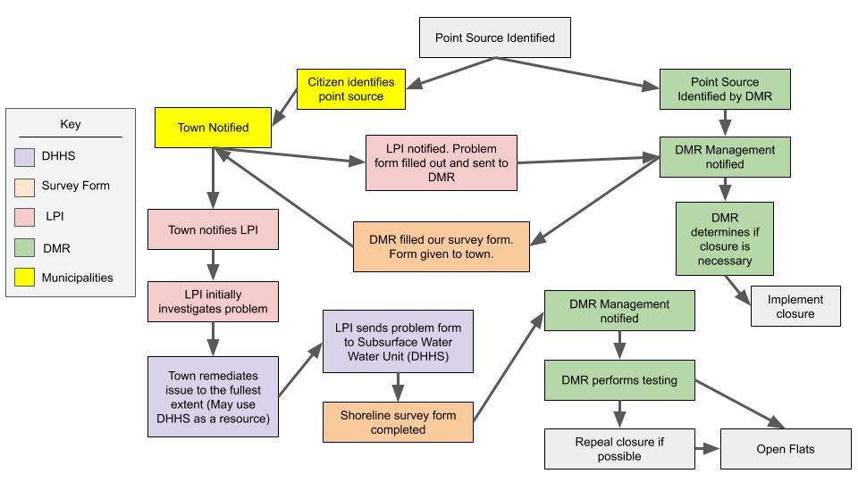
This graphic highlights the major steps any community trying to help solve water quality issues should be taking. More details are posted below.

How are Point Source Pollution Sources Fixed?

This guide outlines how point sources are identified, how information is moved between the Department of Marine Resources (DMR), the town, the licensed plumbing inspector (LPI) and the Subsurface Wastewater Unit at the Maine Department of Health and Human Services (DHHS), and finally, how point sources can be remediated. This is by no means exhaustive, and there are many different ways to tackle this problem. This guide instead hopes to illuminate the decision making process around point sources.

Point Source Identified

Point source pollution is identified in one of two ways, either by a private citizen, or by the Department of Marine Resources (DMR) during a shoreline survey. If identified by a citizen, the issue is reported to town management, and then reported to the DMR. From there, in both instances, problem forms are generated by the DMR.

The Problem Form

A problem form is a detailed document outlining the cause of pollution (to the extent possible), the location of the cause, a general estimate of how long it has been there, and anything else pertinent to the cause. For example, if a straight pipe is found, a problem form would include where the straight pipe is, how large of a problem it is causing, and possible ways to fix it. The DMR fills out and sends the form to the town, who is then responsible for remediation.

Town and Licensed Plumbing Inspector

The town begins by contacting a state licensed plumbing inspector (LPI). This inspector works throughout the state, and is paid to investigate and get more details about the issue. With our example of the straight pipe, the LPI would visit the site, confirm what the problem form had said, and add any more details that can be discovered, such as where that straight pipe comes from.

Remediation

The town is responsible for remediation. This could include a lengthy process of fundraising, hiring construction crews, and is all highly dependent on the shape and extent of the pollution problem. Generally towns should try to consult with the LPI or the DMR before engaging in any specific remediation in order to make sure that it will in fact fix the problem. Another group the town can consult with is the Subsurface Water Unit at the Department of Health and Human Services (DHHS).

Subsurface Water Unit (DHHS)

The Subsurface Wastewater Unit at DHHS is a group of people who work with overboard discharge systems and other wastewater problems across the coast. They have a deep knowledge and understanding of potential remediation techniques, which will be effective, and to what extent the problem can be fixed. Towns should reach out to DHHS for their support and expertise throughout the process of remediation and if they have any difficulties with the LPI scheduling.

DMR - Testing and Revisiting

After remediation is performed to the fullest extent by the town, the town has to schedule another inspection with LPI to complete the problem form. The Subsurface Water Unit from DHHS can also complete the problem form. After this form is completed it needs to be sent to DMR water quality managers. When applicable, the DMR will revisit the site, perform a series of tests, and repeal closures if possible. This process can take a great deal of time, so it is important to keep the DMR, DHHS, and other organizations as up to date as possible as remediation continues.

Water Quality Information Types

This page is dedicated to providing communities with detailed information on the many sources of information around water quality in Maine. It should be noted, this is a guide that will be updated on a yearly basis with new contact information.

Shoreline Survey Information - DMR

Shoreline Survey information is recorded survey information generated every few years by the Department of Marine Resources. There should be detailed notes on areas surrounding tidal areas and clam flats. These notes contain information about any potential problems, wildlife in the area, along with general descriptions. Specific problem areas that are seen during surveys are generally written up in problems forms and submitted by the DMR to the town office. This information is a great starting point for communities to get a better lay of the land on understanding issues in the area.

P90 Scores - DMR

P90 scores are scores generated from water tests taken by the Department of Marine Resources. Each water sample is taken and tested for bacteria (fecal coliform). Based on the amount of bacteria in the sample, the sample is given a score. These scores are averaged over a multi-year period to generate closure areas (prohibited, conditional, open, and restricted). High scores mean there are large amounts of bacteria in the water at the time of sampling. Looking at these scores should give a community an idea about hot spots, or specific testing sites that have high scores. These areas are indicative of an issue, either a point source that most likely has been noted on a shoreline survey (see above) or a non-point source.

Tax Maps - DEP

These maps, along with others, can highlight where private land may influence coastal areas. This, along with an understanding of shoreline surveys and P90 scores can help shape studies to try and find and fix pollution.

Problem Forms - Town Manager’s Office

These are forms submitted to the town by the Department of Marine Resources to a town, outlining issues they have seen on shoreline surveys that require remediation. This remediation is a responsibility of the town, community, or shellfish committee to fix. After remediation has been performed, the DMR is able to test quickly and thoroughly for improvements to water quality scores.

