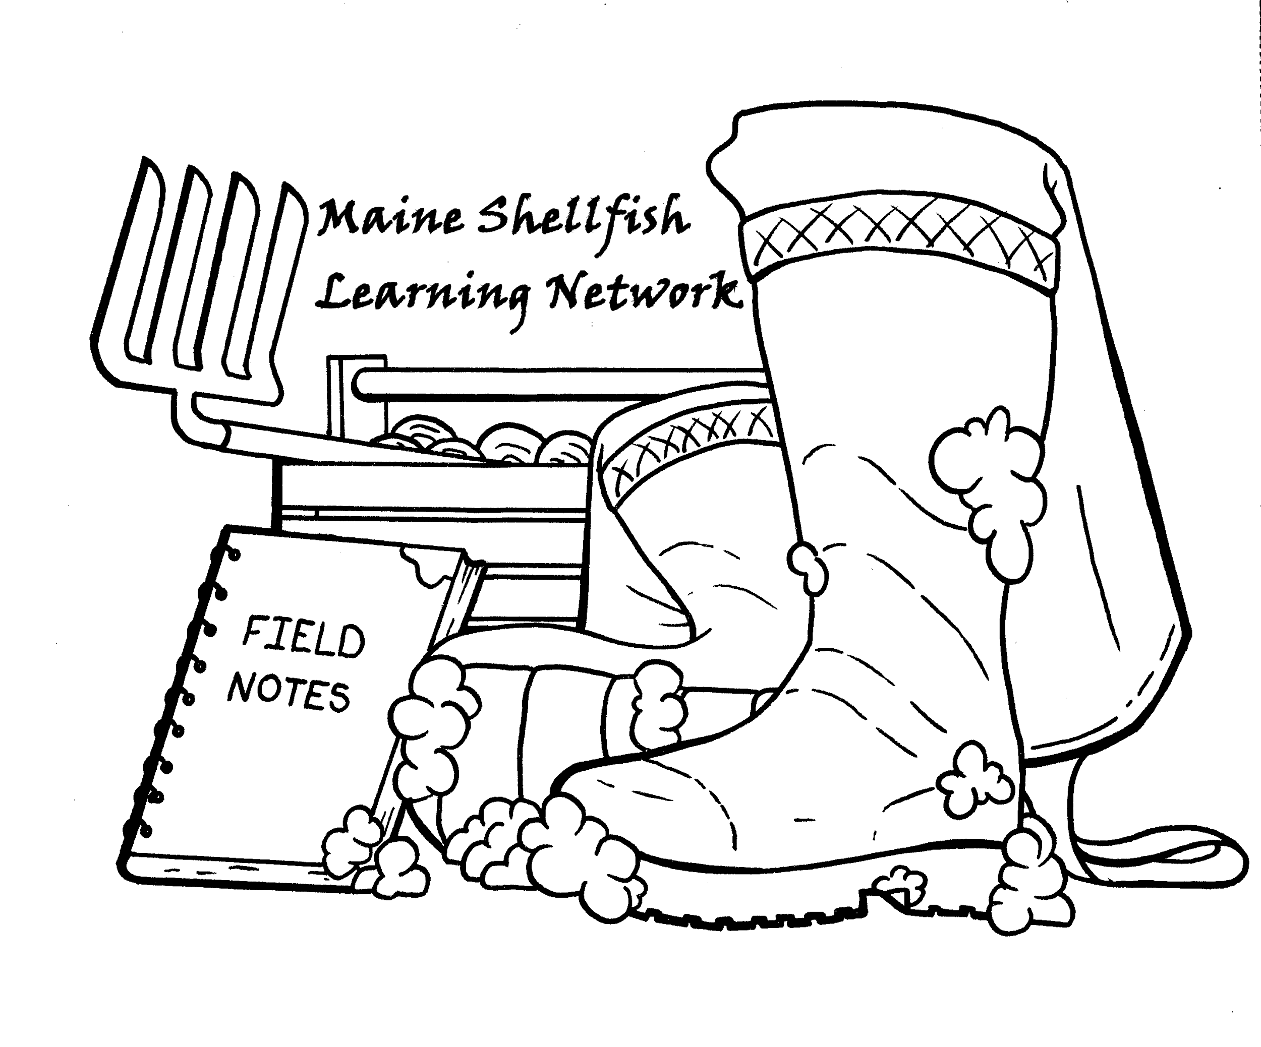

Microbial Source Tracking Technical Brief

Completed in collaboration from the Maine Shellfish Learning Network

Dr. Steve Jones, UNH, Gabrielle Hillyer, UMO

Summary

Microbial Source Tracking (MST) is a type of water quality testing. This test focuses on fecal coliform bacteria. These bacteria come from fecal pollution sources, either from animal or human waste. They can cause a variety of diseases, so managers of coastline areas close down spaces depending on the levels of these microbes. MST determines if there is fecal pollution, and can help identify if the pollution is coming from key animal groups or humans. It has been used by a variety of projects in Maine, including Maine Healthy Beaches and the Medomak Taskforce. This type of testing gives managers information, so they can make better decisions about how to stop pollution from entering the water, or how to manage areas around waterways. This type of testing is usually done when the focus is primarily on determining what type of pollution is occurring, not just if there is pollution or not.

Below is a rather simplistic model of how this testing works. First, communities would take water samples, and determine if there is a presence of fecal coliform bacteria. Usually, this would include testing at the Department of Marine Resources. Then, the samples should be sent s to appropriate lab spaces either at the University of New Hampshire or the University of Maine Machias. These labs would then extract DNA and compare it to other DNA from animals or humans to determine where the bacteria is coming from. Once a comparison is made, it can be determined to a certain degree where pollution is coming from.

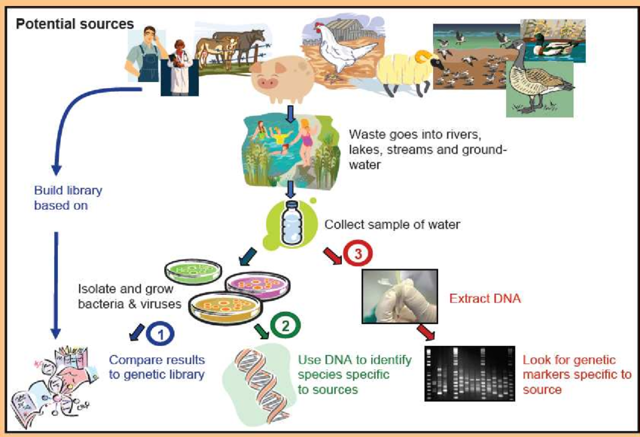
https://www.researchgate.net/figure/Concept-of-Microbial-Source-Tracking-Image-Courtesy-United-States-Environmental_fig3_264011114
To be clear, this method is primarily exploratory, meaning it does not resolve any specific water quality issue but instead helps communities find the source. Further action and research will have to follow up on these results to determine how and if the source can be cleaned up.

Things You’ll Need

- Water Sampling Kit
- Preliminary Bacteria Testing Lab
- MST testing laboratory
- Multiple volunteers

Who to Contact to Get Started:

Stephen Jones - stephen.jones@unh.edu
Bryant Lewis - bryant.lewis@maine.gov
Gabrielle Hillyer - gabrielle.hillyer@maine.edu
Amanda Moeser - amoeser@antioch.edu
David Miller - david.w.miller@maine.gov
Pamela Parker - Pamela.D.Parker@maine.gov
Bridie McGreavy - bridie.mcgreavy@maine.edu

